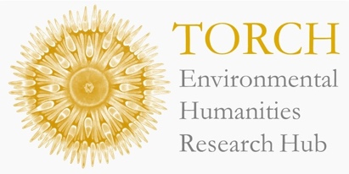



Waste
Methodologies
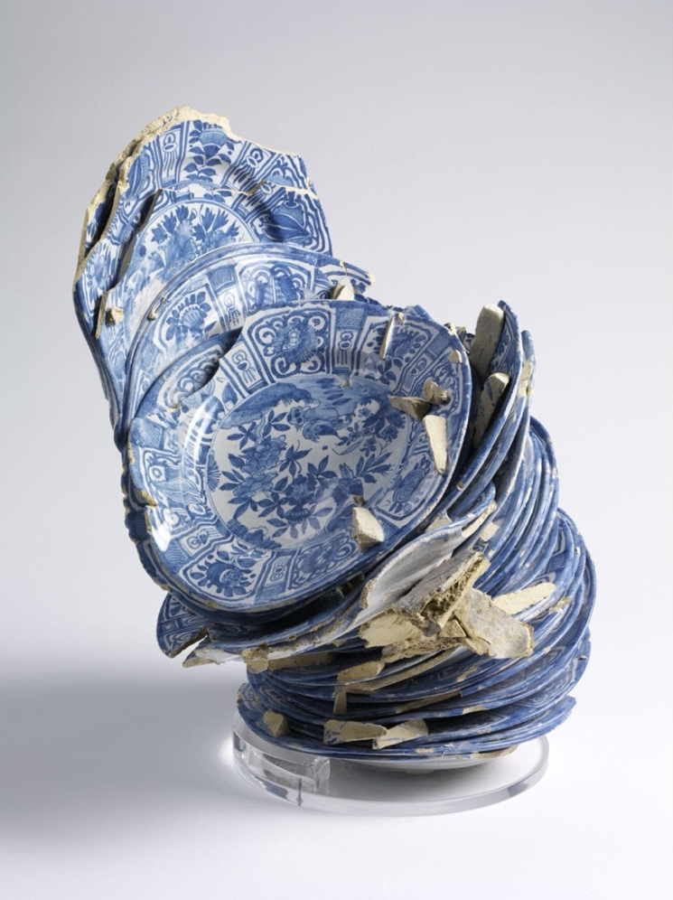

Waster, unknown (1650-1670), V&A

Thursday 23rd of October
12:00-1:30pm
Schwarzman Centre

* If you would like a free lunch at this session, please pre-register here.

In collaboration with Dr Ruth Ezra and Dr Francesca Borgo (Art History, University of St Andrews), this seminar hosts early career researchers to present creative methodological approaches to studying waste materials from the archive to the field:

- Aishwarya Mukhopadhyay (Anthropology, Oxford). Following the Dustbin: Stories of Waste and Governance in Siliguri, India.

- Dr. Eiko Soga (Fine Art, Oxford). Traditional Ainu Cooking Among More-Than-Human World in Samani in Hokkaido, Japan.

- Mwangi Mwaura (Geography, Oxford). Sales Dairies: Mathematics of Harm, Evidence of Planetary/Environmental Stewardship.

- Dr Martha Swift (English, Oxford). Rubbish, Recycling and Regeneration: Chinese Science Fiction and Creating with Waste.

This seminar is followed by an interdisciplinary workshop bringing together a small group of researchers. Please reach out to the E.H. Research Hub if you are interested in joining.

