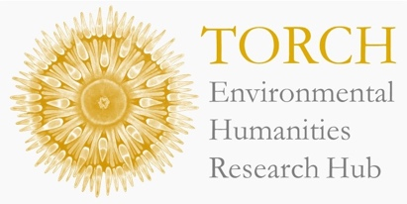



Reclaiming Land for the Future:
Coal, Environmentalism, and Population in Post-1945 Britain

Dr Andrew Seaton (University College London)

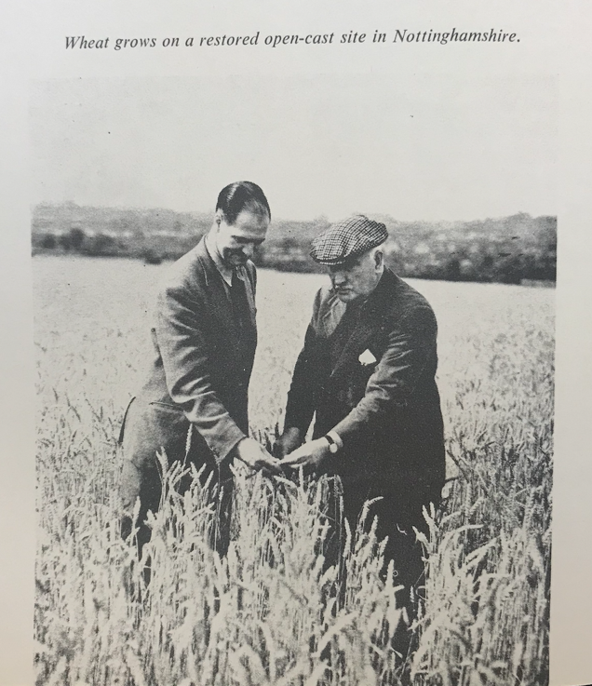

Wheat Grows on a Restored Open-Cast Site in Nottinghamshire, National Coal Board.

Thursday 4th of December
12:00-1:30pm
Schwarzman centre

* If you would like a free lunch at this session, please pre-register here.

Dr Andrew Seaton will be discussing a chapter from his book project, The Ends of Coal, which is a wide-ranging environmental history of the resource's impacts and legacies in Britain and the world since 1800. This talk considers the National Coal Board's expansive 'land reclamation' initiatives after 1945. These projects facilitated surprising connections between one of Europe’s largest fossil fuel industries and environmentalists, particularly by creating ‘productive’ land that might alleviate potential scarcity caused by ‘overpopulation’. The talk considers the practical dimensions of the Coal Board's land reclamation, recovers its framing and reception, and explains how initial justifications fell away in the 1980s.

The chapter will be discussed by Professor Danny Dorling (Geography, Oxford).

Dr Andrew Seaton is a Leverhulme Early Career Fellow at University College London. He is a historian of modern Britain with interests in politics, social history, medicine and the environment. Andrew's first book Our NHS: A History of Britain's Best-Loved Institution (Yale University Press, 2023) won the American Historical Association's Morris D. Forkosch Prize and was shortlisted for the Wolfson History Prize.

